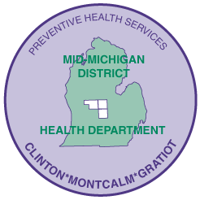
MID-MICHIGAN DISTRICT HEALTH DEPARTMENT
Your public health team, connecting with our communities to achieve healthier outcomes

Submitted by: Leslie Kinnee, Public Information Officer
615 N. State St., Stanton, MI 48888-9702
989-831-3669, lkinnee@mmdhd.org

www.mmdhd.org


FOR IMMEDIATE RELEASE: 11-8-16

Health department announces ACE Award winner

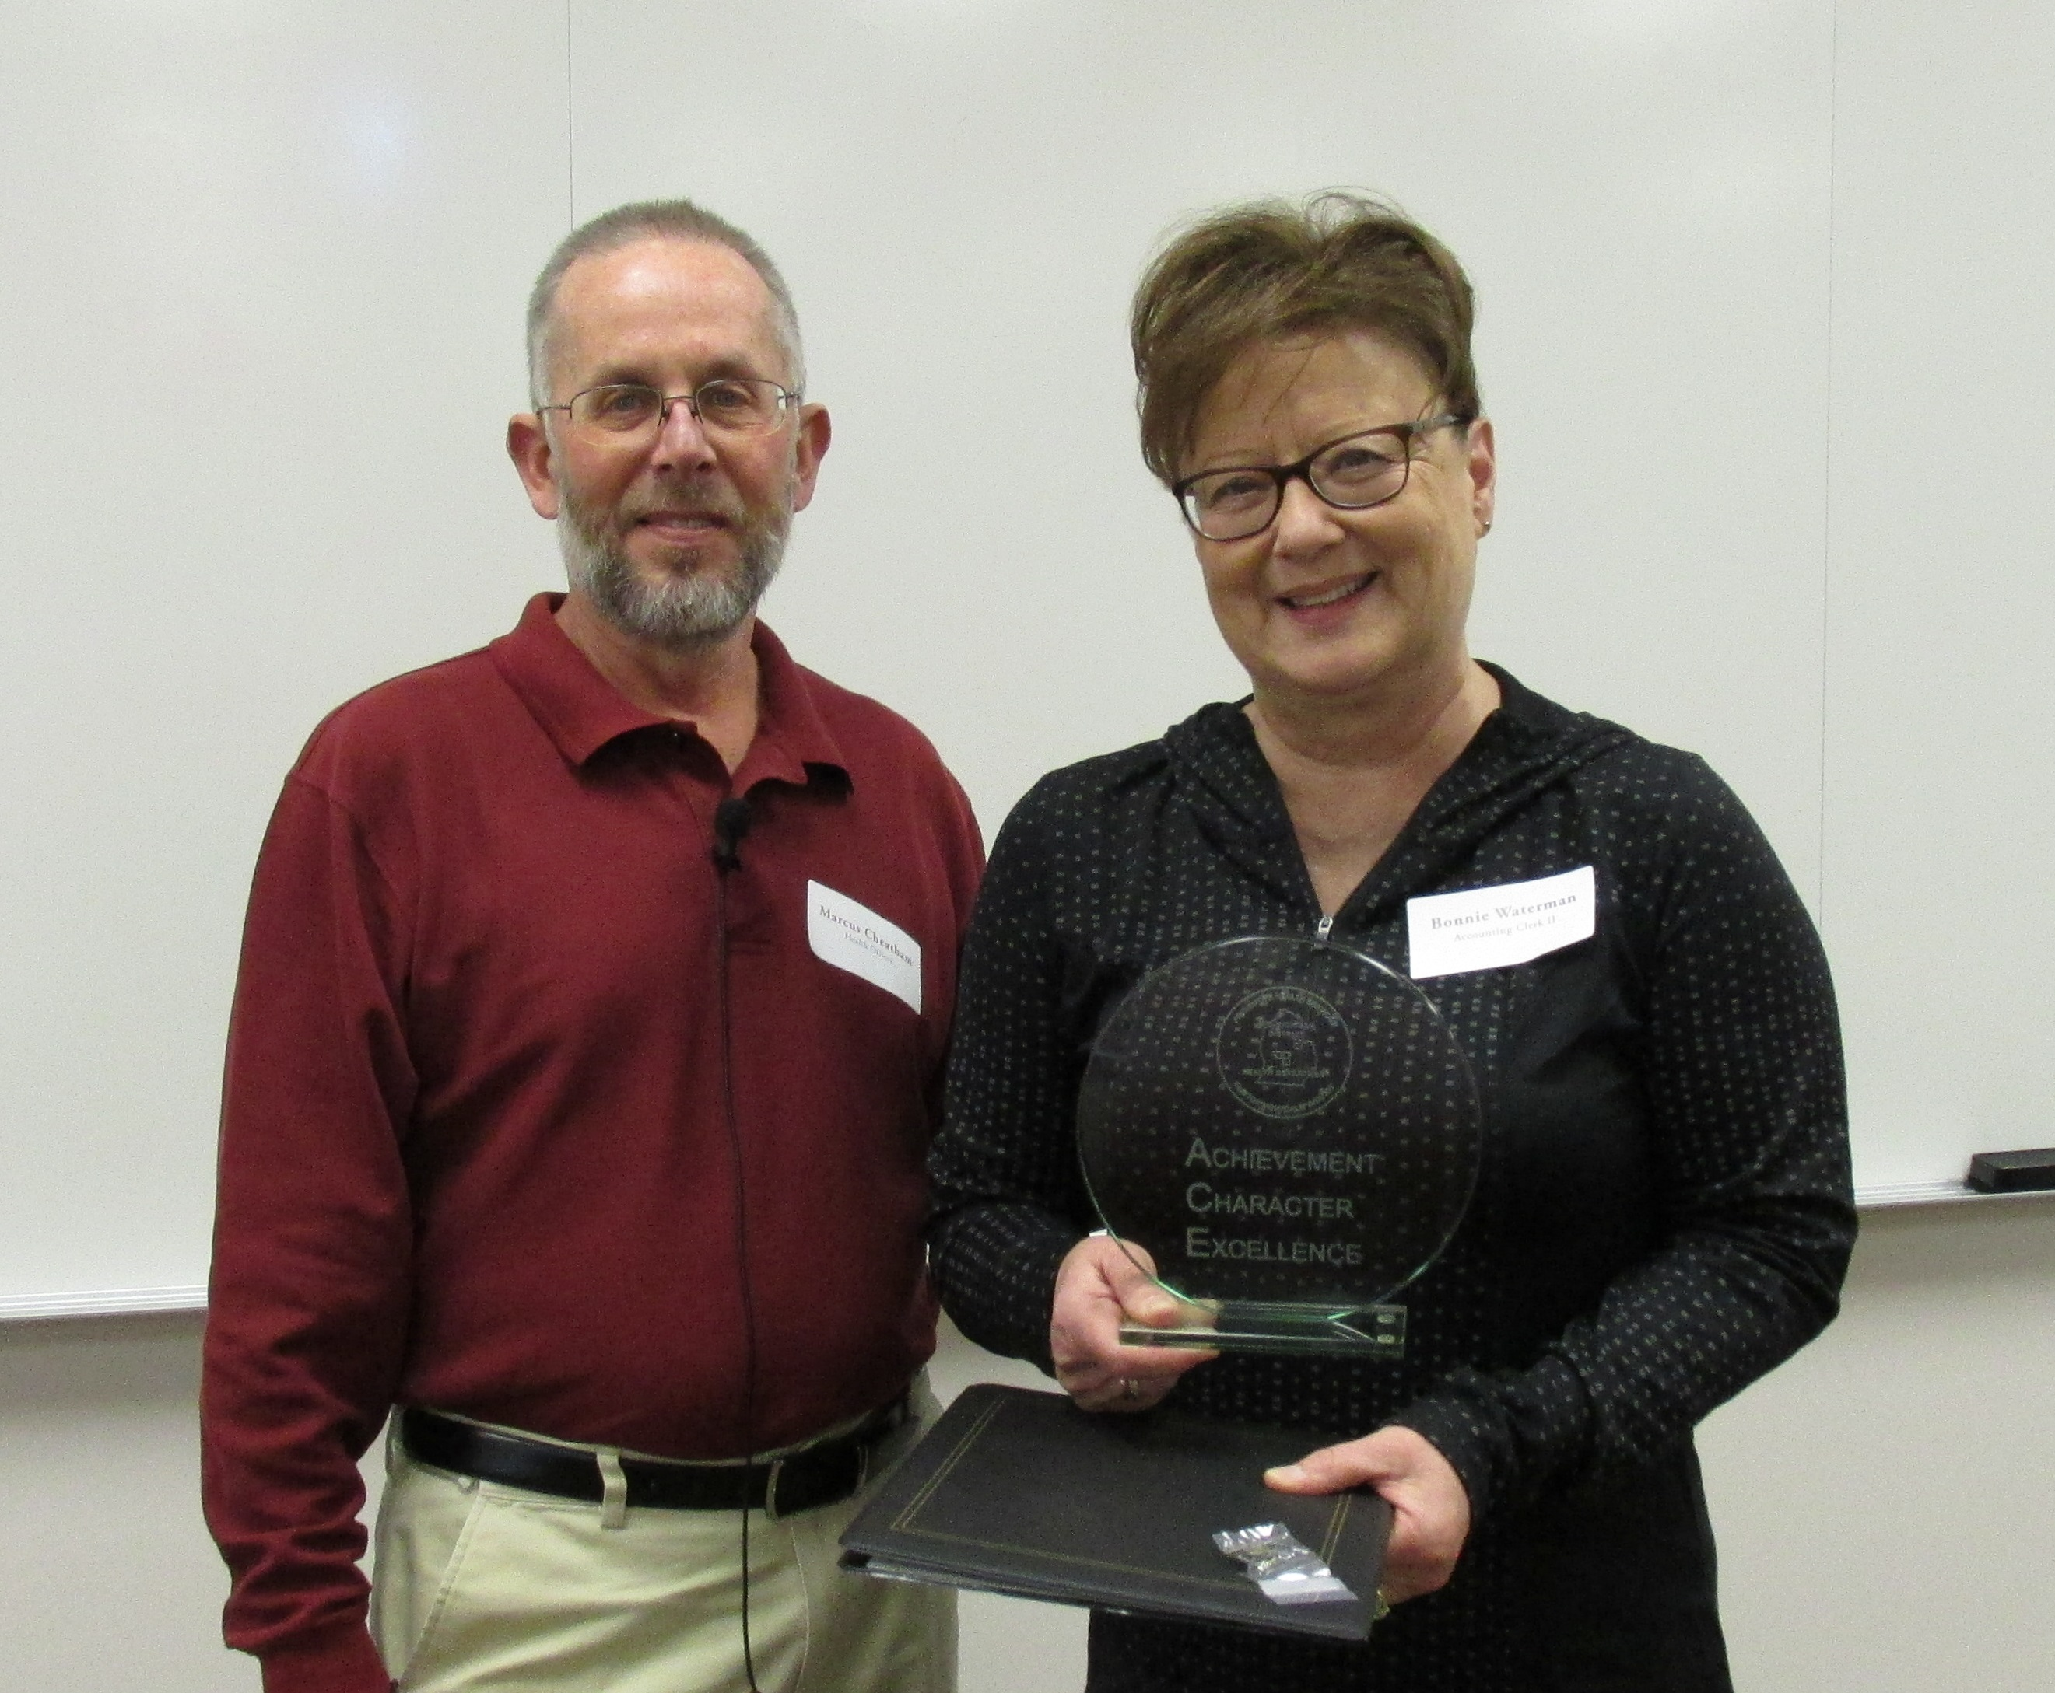

Marcus Cheatham, Mid-Michigan District Health Department’s
Health Officer, presents the ACE Award to Bonnie Waterman,
Accounting Clerk II

Stanton- Mid-Michigan District Health Department (MMDHD) is pleased to announce that Bonnie Waterman, Accounting Clerk II, was chosen by her peers to receive the ACE (Achievement, Character, Excellence) Award for the period July - September, 2016.

Waterman received multiple nominations from co-workers, who feel she has done a remarkable job with billing. They also admire her great attitude, hard work and commitment to being a team player.

Mid-Michigan District Health Department would like to thank Waterman for her dedicated service to the agency and congratulates her on winning the ACE Award.

ACE Award recipients are chosen by their colleagues and have proven to demonstrate achievement, character and excellence in all they do at MMDHD.

Mid-Michigan District Health Department serves the residents of Clinton, Gratiot and Montcalm Counties.

###

